Ruben Prado

CST-105

October 22, 2017

Charles Lively

NFL Final Milestone #1 Revision

Storyboard

Please see the following additions for the revised story boards from my final project. I have improved the structure of this class project and added so much since the first milestone, I was able to update my project a lot and completed a large portion of my intended design. Most of my changes had been related to style this was done to improve the aesthetic of the program, others where related to the functionality of the program.

The player cards had been a large change that needed to take place it now displays the stats inputted vs just the default. This project was intended to display to the user an option to login and select and save their chosen players along with their class meaning Offence, Defense, Running back and so on. All this work is and has been my own, this project was certainly a challenge and enjoyed writing it and learning how to apply the learned techniques.

**Draft pros**



Username

Password

Don’t have an account? Sign up

**LOG IN**

**Draft LIKE A PRFESSIONAL**

First Name

Email

Last Name

Password

Confirm Password

**SUBMIT**

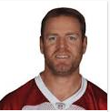

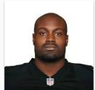

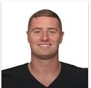

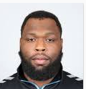

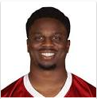

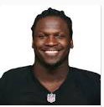

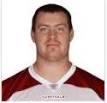

**Draft like a Pro**

*Player Stats*

 

**My Draft Pros**

*Player Stats*















  

**Player Browser**

*Player*

**SEARCH**

**Results (1)**

*Player Stats*



 

**Edit Profile**

**Delete Account**

 

**First Name:**

Ruben

**Last Name:**

Prado

***************

**Password:**

sauryha.gay@nfljets.com

**Email:**

**SAVE**

**BACK**

**Information Page**



Return to home page



search for players



Log out and close Application

Add players

Remove players

**BACK**